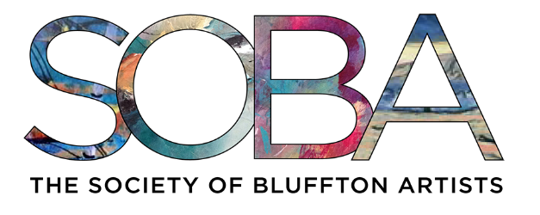

7 CHURCH STREET
BLUFFTON SC 29910

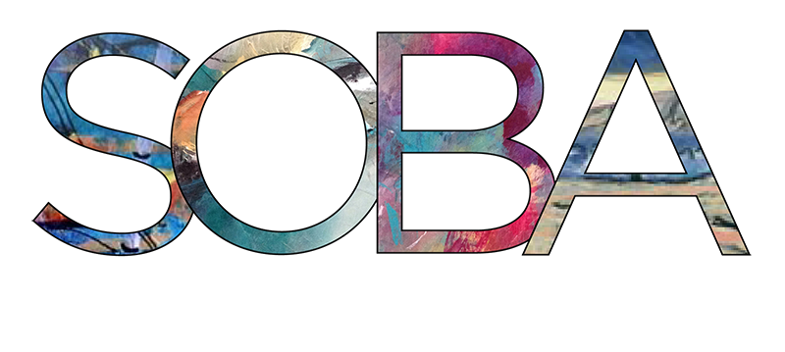

843-757-6586 SOBAGALLERY.COM

Dear Friends & Lowcountry Businesses

The Society of Bluffton Artists will host its 32nd Annual Judged Show September 1st through
October 4th, 2026.Open to all artists in the Lowcountry, the Annual Judged Show showcases outstanding regional talent and has become one of the premier events in our area.

It is also one of Society’s most important fundraising efforts each year and we invite you to partner with us to help to make this highly anticipated and popular event another great success. Your support can help ensure the continued success of this important event while connecting your business with hundreds of residents and visitors who value creativity, culture and community involvement.

Funds raised through this event help us
- Recognize and celebrate exceptional local artists
- Maintain a vibrant and lasting artistic presence in Bluffton
The SOBA Gallery and Art School continue to be a valuable cultural asset, both for our local community and the Lowcountry tourism industry.
As a fellow Lowcountry Business, your sponsorship of the SOBA Annual Judged Show demonstrates your commitment to the arts and to the cultural vitality of our community.

- You will receive tickets to the Members and Sponsors preview reception on August 31 and be
invited to and recognized at the Opening awards Reception on Wednesday September 2nd
- All sponsors will be acknowledged in our marketing materials including social media, print advertisements, our website, and press releases.
- Your logo will be displayed at the SOBA Gallery and on posters prominently displayed about town
- The names or businesses of our top sponsors will be featured on one of 7 First Place Awards
As a 501(c)3 since 2004, the Society of Bluffton Artists depends on art sales, sponsorships, and dedicated volunteers to support our mission of promoting and nurturing the visual arts in Bluffton and the surrounding community. Donations and funds generated through sales at the SOBA Gallery and Art School enable us to provide classes, exhibitions for both adults and youth and community educational programs and events such as our annual High School Art Show and the annual McCracken High School Senior Scholarships for Bluffton High School students pursuing studies in the visual arts.

We sincerely appreciate your consideration and look forward to partnering with you in support of
the arts in Bluffton.

Warm regards,

President - The Society of Bluffton Artists

32nd Annual Judged Show Sponsorship Form
You may donate online by going to sobagallery.com, by scanning the QR code below or fill out the form below and mail to our address.
As a Judged Show Sponsor, you will
- Be acknowledged in our marketing materials including press releases, social media, print advertisements and our website.
- Be Invited to and recognized at the Opening Awards Reception on Wednesday September 2nd
- Receive invitations to the private Sponsors & Artists preview Reception August 31st
Meet the participating Show Artists, the Judge of the 32nd Judged Show, Patrick Reid O’Brien Have advanced opportunity to purchase artwork prior to display to the public on September 1st
- Have your name or business name and logo listed in both Event Programs and Top sponsors will also have their name or business as Sponsors of the Show Awards.

The First Sponsor of $1500 or more
- Your name or business name will be titled as sponsor of the highly coveted Best in Show Award
- Receive 10 tickets to the private Sponsors and Members Only Preview Reception August 31st
Sponsors of $1000 and up
- Your name or business will be named as sponsor one of the First Place Awards in one of the
seven categories
- Receive 8 tickets to the private Sponsors and Members Only Preview Reception August 31st
Sponsors of $500 to $999
- Receive 6 tickets to the private Sponsors and Members Only Preview Reception August 31st
Sponsors of $250 to $499
- Receive 4 tickets to the private Sponsors and Members Only Preview Reception August 31st
Sponsors of $100 to $249
- Receive 2 tickets to the private Sponsors and Members Only Preview Reception August 31st

Name and/or business:
Address:
Contact Name:
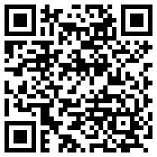
Phone: Email:
SCAN TO DONATE ONLINE

SOBA GALLERY, P.O. BOX 1972, BLUFFTON, SC 29910 sobagallery.com

